WLXRF spectroscopy of Sasanian silver coins and Economic Reform During Hephthalite Invasion: New Evidence

Babak Niloufari
Faculty of restoring historical Monuments of Tabriz Payam-e-Nour University, Tabriz, Iran.
Hassan Karimian
Assoc Prof, Dept of Archaeology, Tehran University, Tehran, Iran.
Farhang Khademi Nadooshan
Assoc Prof, Dept of Archaeology, Tarbiat Modares University, Tehran, Iran.

Abstract
The Sasanian Kingdom (224-651 CE), which underwent several economic crises, were forced to reform their currency even when they paid tribute to the Hephthalite kings which did not have knowledge of coin issuing.

Their metrology indicates that several reforms had occurred during their time, but so far a few studies have been carried out concerning the reformation and its effect on the chemical composition of the coinage.
In this article, an attempt has been made to show tribute coins, which had been paid to Hephthalite and other Central Asian tribes.
We will do spectroscopy using WLXRF spectroscopy to find the chemical composition of Sasanian coins which had been devaluated for the purpose of issuing more coins to the Heptalite king.

Keywords: Sasanian kings, Hephthalite kings, mint issue, coins, WLXRF.

Introduction
Coins which are interpreting archaeological and historical points, their chemical compositions hint to the several social events in their era. Mint houses, due to the sources of metal geologically and technically have different chemical compositions. And therefore, their regular till occasional issues give information about the crises and inflammation. These Sasanian kings in time of prosperity until a war changed the value of coins but in time.

Historical Background
Mesopotamian and Greeks writers gave valuable information about Eastern Iran of the Achaemenid period (559-330 BCE). Greek writers stated that Cyrus II (559-530 BC) had been killed in war with northern tribes. When Alexander invaded Achamenian territory in back of Darius III (Frye 1962: 157) the last king of this dynasty entered to the north east of Iran where he was killed in the place near today Shahrud in north east of Iran and Dynasty of Achamanean came to an end. In Seleucid period (312-64 BCE), Antioch us (280-262 /261 BCE) was the joint ruler of his father in Marv and re-established Marv in his name as Margiana Antioch (Bevan 1902: 14). Later on Greeks of Bactria were pushed down to the south of Hindu Kush by these Central Asian tribes.
Since two Parthian king, Phraates II (139/8-128 BCE) and Artabanus (129-124/3 BCE), were killed in the war with these Central Asian tribes, a wall was built by the Parthian in other to prevent further invasions by these tribes (Bivar 1993: 38).
When Ardeshir I (224 - 241 CE) founder of Sasanian dynasty (Map I) took the power from Parthian, who already were in the fight with Kushan in their north eastern border next king, Shapur II (Gobel 1971: 66) after defeated Hephthalite, a new comer of Central Asian tribes and force them to the joint his army against the Romans. Hephthalite (Frey 1993: 147) which after Kidarate has appeared by their present beside Sasanian (224 - 651 CE). After a long period Vahran V which defeated Hephthalite for a short while there was peace in Sasanian borders.
By coming Piroz again clash has been started between Sasanian and Hephthalite captured him, and force to Sasanian to pay tribute to them, since finalize due his son Gubad had been left to them, after him. Belash sated on the throne, and his times were emerging of Mazdak, which was social reform in between his territory. Again in time of Khusro I Turkish Khaghan appeared in border of Sasanian territory.
Hephthalite which after facing Sasanian and destroyed their cities, parts of them were migrated to Indian land (Mitchiner 1978: 492) and on there, facing mighty Gupta Dynasties and later settled in northern part of India and there issued several imitating types of coins from local and Sasanian dynasties. Besides of this migration and appearing of Turkish tribes in the north eastern of Iran, Khusro, I had concluded territory with them and his son Hormuz IV (Gobl 1971: 69) been from mother side from them. He gave his place to Vahran VI, and Xhusro II was the last powerful king of Sasanian dynasty.
Problem investigation
Mint issues were the main official place for minting of currency, controlled directly for the economic and political purpose. Their composition gave official information about debasement (Guerra 1995: 583-588) and forgery. Their major and minor elements and trace elements gave information about the probable sources.
Our information about the constitution of a mint house is very little. There is no any written document about the administration of mint houses, and controlling of composition of metallic forms of coins.
Our investigation shows Alexander issued bullion coins. Nearly all the Alexander coins are pure gold and silver (Kallithrakass_Kontos. & et al, 2000: 342-349) From Seleucid period when they politically settled in Iran copper were added to silver intentionally due to different factors.
The Same system of economic policy was continued in Parthian period and never Iron observed in their chemical composition (Caley 1955: 129) to be as an intentional addition to the coins.
Spectroscopy of several silver coins from Alexander until Sasanian period shows there is an exception for Sasanian, from the reign of Vahran V and appearing of Hephthalite due to the political situation and war with the Central Asian tribe's new series of coins had been minted by the Sasanian king for their defeating and paying of tributes (Gobl 1971: p69). Naturally, these new series of coins with new chemical composition for paying huge amount of tribute by adding of Iron metal as intentional additions were issued.
These coins which mostly paid as a tribute to the Hephthalite and invaded tribes of north eastern side were those people who do not have any monetary background in their political presentation and when they met Sasanian or other later king in the way of their travel adopted their issues.
The spectroscopy of these Sasanian coins shows the government policy by adding copper as additional metal trying to control the crises and inflammation which to be observed in their territories, but some policy must be basically applicable to the Sasanian king whom they are issuing coins for paying as the tribes.
For this purpose, WLXRF spectroscopy over Sasanian coins which has done in our faculty of Basic Science which instrument has been made by the Philips Company, shows from Alexander to the Sasanian besides copper, Iron is observable in Sasanian issues. From Alexander until Sasanian, those coins which had been put for spectroscopy other than Sasanian Iron for the first time to be added.

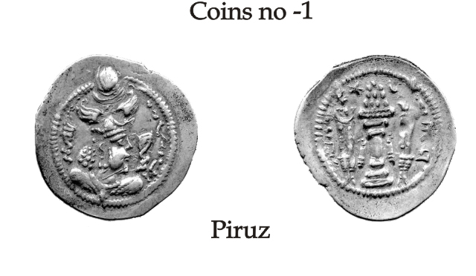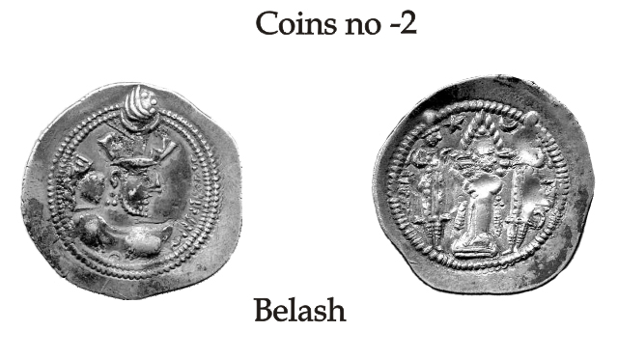
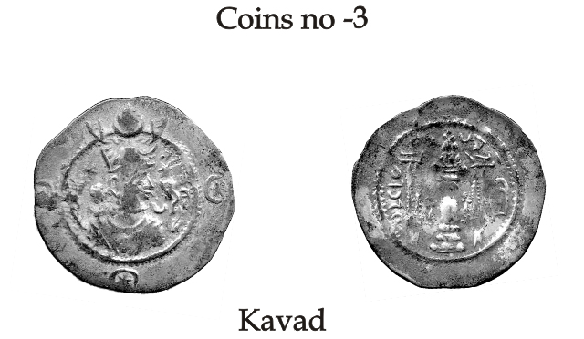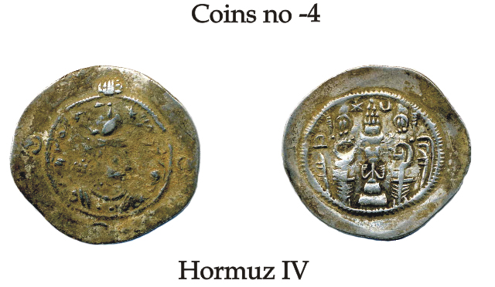
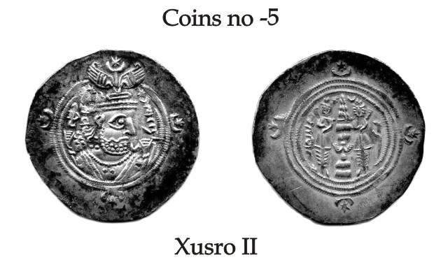

Plate.1

Sample preparation
All the coins were cleaned before spectroscopy by alcohol and acetone, as Kallithakas_ Kontes reported, "large difference before and after cleaning in their amount, especially Cl, Ti and Mn, the same has been reported by Uzonyi (Uzonyi. I. & et al. 2000: 748-752) as the surface contamination or inclusions present in the sample.
Table 1: Sasanian coins
Coin no | King name | Unit weight | Mint house | Regnal year | weight | Diameter
1 | Piroz | Dirham | Ardeshir Khurre | … | 3.77 | 2.8
2 | Belash | Dirham | Ardeshir Khurre | … | 4.11 | 2.9
3 | Ghobad | Dirham | Istakhr | 25 | 4.10 | 2.7
4 | Hurmuz IV | Dirham | Bishapur | 9 | 4.08 | 3.15
5 | Khusro II | Dirham | Ardeshir Khurre | 35 | 4.14 | 3.20

Table 2: XRF spectroscopy of Sasanian coins*
Coin no | Ag | Cu | Fe | Ca
1 | 91.371 | 1.289 | 2.013 | 0.681
2 | 82.531 | 1.326 | 7.188 | 0.947
3 | 72.083 | 6.455 | 3.524 | 1.904
4 | 81.371 | 0.579 | 1.136 | 11.111
5 | 83.948 | 1.98 | 1.112 | 0

*rest of chemical element does not report here.
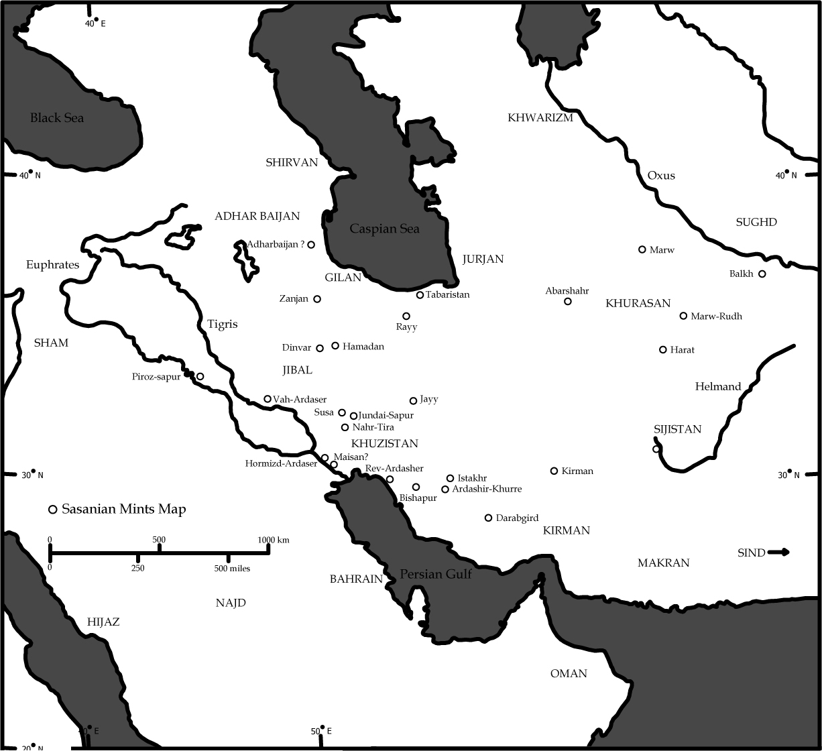Map.1
Result and discussion
Sasanian a contemporary dynasty to Romans had issued new technique of coins with several reformations in their metrology from their predecessors.
They not only forced to face economic crises but also to paid tribute coins to the several migrated tribes, which were defeated Sasanian kings. Among of their predecessor's issues, their chemical compositions are an exception, and that Iron has been appeared on these Sasanian kings (Table, I $ Plate I) ) issues which face to be paid tribute to Hephthalite and other tribes like Turkish tribes.
Their chemical composition (Table 2) shows silver contents do not suffer from the severe political condition. Copper which shows added for politico-economic adjustment remains nearly constant. And intentionally Iron was appear in this period. Which shows those lead zinc silver mines have been used which has the( V.Kantarelou & et al, 2011:8) Iron as impurities. Among the Sasanian coins which had been minted for paying of tribute by Sasanian king to the Hephthalite has been mentioned.
Possibly, there is a difference between tribute payment and inflammation crises, which may be observable by addition of copper to the silver issues. In the official tribute issues in the Sasanian period impurities were Iron due to use of new sources of mines which appear in several Sasanian silver issue minted for currency. Irons which have high oxidization affinity ( No 1-5) may be due to lose their weight in the specimens. And naturally obverse and reverse of coins became darker and lose in the weight.
It is not clear why These Sasanian kings exploring those mines which Iron has high percentage and make low value of their issues, it was intentionally and unintentionally it is not clear to us.

Bibliography
- Bevan.E.R, 1902, The House of Selucuc, volume I, London.
-Bivar. A.D.H., 1993,"The Seleucid, Parthian and Sasanian period", The Cambridge History of Iran, Vol 3(1) Cambridge.
- Caley. E., 1955,"the Chemical composition of Parthian coins". American Numismatic Society, Numismatic note and monographs, 129. - Frye.R.N, 1993, "The Sasanian period", The Cambridge History of Iran, Vol 3(1) Cambridge.
- Frye.R.N , 1962, the Heritage of Persia, London.
- Mitchiner.M., 1978, "oriental coins and their values", The Ancient and Classical world, London.
- Gobl.R., 1971, Sasanian numismatics, Vienna.
- Guerra.M.F., 1995, "Elemental Analysis of Coins and Glasses", Appl Radiant Isot.Vol. 46. No 6/7.
-Nallithrakass_Kontos. N., A.A.Kastsanos., J.Touratsoglou., 2000,"Trace Element analysis of Alexander the Great's silver tetradrachms minted in Macedonia", Nuclear Instruments and Methods in Physics Research B, 171.
- Uzonyi. I., R. Bugoi., A. Sasianu., A. Z.Kiss., B. Constantinsecu., M.Torbagyi., 2000, "Characterization of Dyrrhachium silver coins by micro-PIXE method", nuclear instruments and methods in Physics research B ,161-163.
Kantarelou. V., & et al, XRF analytical criteria to ass the finness of ancient silver coins: Application on Ptolemaic coinage, Spectrochimica Acta- Part B Atomic Spectroscopy, 2011: in press

